**FAST NATIONAL UNIVERSTIY OF COMPUTER AND EMERGING SCIENCES, PESHAWAR**

**DEPARTMENT OF COMPUTER SCIENCE**

**CL1200 –Introduction to the information and communication technology LAB**



**Introduction to ICT**

**LAB MANUAL # 2**

**Instructor: Mazhar Iqbal**

**SEMESTER FALL 2023**

#### Mouse alternatives:

There are other devices that can do the same thing as a mouse. Many people find them easier to use, and they also require less desk space than a traditional mouse. The most common mouse alternatives are below.

* **Trackball**: A trackball has a ball that can rotate freely. Instead of moving the device like a mouse, you can roll the ball with your thumb to move the pointer.
* **Touchpad**: A touchpad—also called a **trackpad**—is a touch-sensitive pad that lets you control the pointer by making a drawing motion with your finger. Touchpads are common on laptop computers.



#### *Buttons and Ports on a Computer*

### Introduction:

Take a look at the front and back of your computer case and count the number of **buttons**, **ports**, and **slots** you see. Now look at your monitor and count any you find there. You probably counted at least 10, and maybe a lot more.

Each computer is different, so the buttons, ports, and sockets will **vary from computer to computer**. However, there are certain ones you can expect to find on most desktop computers. Learning how these ports are used will help whenever you need to connect something to your computer, like a new printer, keyboard, or mouse.

### Front of a computer case:

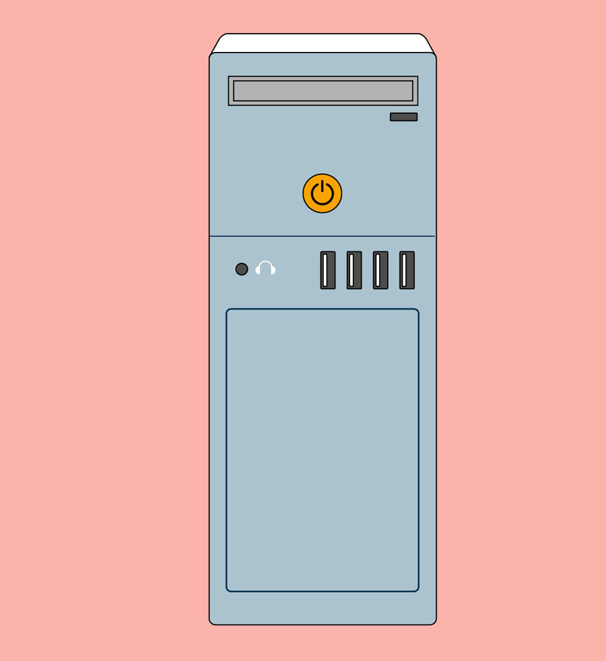

### Back of a computer case:

The back of a computer case has **connection ports** that are made to fit **specific devices**. The placement will vary from computer to computer, and many companies have their own special connectors for specific devices. Some of the ports may be **color coded** to help you determine which port is used with a particular device.

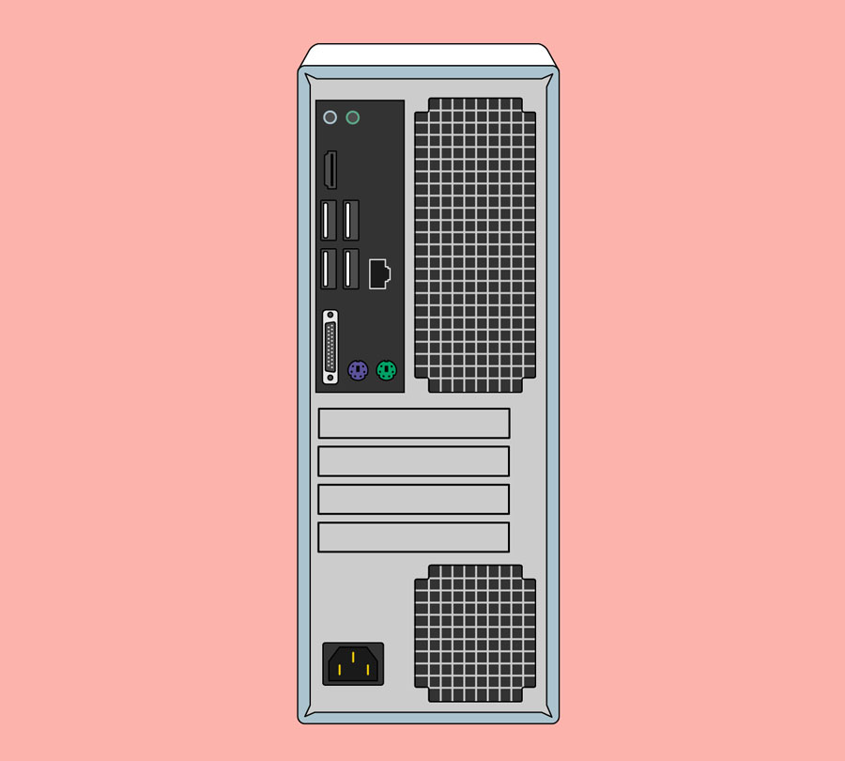

### *Peripherals you can use with your computer:*

The most basic computer setup usually includes the **computer case**, **monitor**, **keyboard**, and **mouse**, but you can plug many different types of devices into the extra ports on your computer. These devices are called **peripherals**. Let's take a look at some of the most common ones.

1. **Printers**
2. **Scanners**
3. **Speakers/headphones**
4. **Microphone’s**
5. **Game controllers and joysticks**
6. **Mobile phones, MP3 players, tablet computers, and other devices**:

### *Inside a computer*

Have you ever looked **inside a computer case**, or seen pictures of the inside of one? The small parts may look complicated, but the inside of a computer case isn't really all that mysterious. This lesson will help you master some of the basic **terminology** and understand a bit more about what goes on inside a computer.

#### Motherboard:

The **motherboard** is the computer's **main circuit board**. It's a thin plate that holds the CPU, memory, connectors for the hard drive and optical drives, expansion cards to control the video and audio, and connections to your computer's ports (such as USB ports). The motherboard connects directly or indirectly to every part of the computer.

#### CPU/processor:

The central processing unit (CPU), also called a **processor**, is located inside the **computer case** on the motherboard. It is sometimes called the brain of the computer, and its job is to carry out commands. Whenever you press a key, click the mouse, or start an application, you're sending instructions to the CPU.

The CPU is usually a **two-inch ceramic square** with a **silicon chip** located inside. The chip is usually about the size of a thumbnail. The CPU fits into the motherboard's **CPU socket**, which is covered by the **heat sink**, an object that absorbs heat from the CPU.

A processor's **speed** is measured in **megahertz (MHz)**, or millions of instructions per second; and **gigahertz (GHz)**, or billions of instructions per second. A faster processor can execute instructions more quickly. However, the actual speed of the computer depends on the speed of many different components—not just the processor.

#### RAM (random access memory):

RAM is your system's **short-term memory**. Whenever your computer performs calculations, it temporarily stores the data in the RAM until it is needed.

This **short-term memory disappears** when the computer is turned off. If you're working on a document, spreadsheet, or other type of file, you'll need to **save** it to avoid losing it. When you save a file, the data is written to the **hard drive**, which acts as **long-term storage**.

RAM is measured in **megabytes (MB) or gigabytes (GB)**. The **more RAM** you have, the more things your computer can do at the same time. If you don't have enough RAM, you may notice that your computer is sluggish when you have several programs open. Because of this, many people add **extra RAM** to their computers to improve performance.

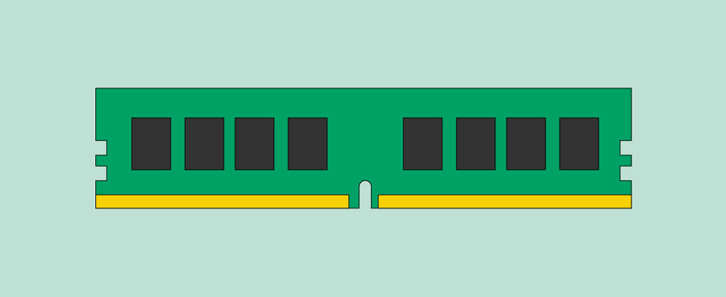

#### Hard drive:

The **hard drive** is where your software, documents, and other files are stored. The hard drive is **long-term storage**, which means the data is still saved even if you turn the computer off or unplug it.

When you run a program or open a file, the computer copies some of the data from the **hard drive** onto the **RAM**. When you **save** a file, the data is copied back to the **hard drive**. The faster the hard drive, the faster your computer can **start up** and **load programs**.

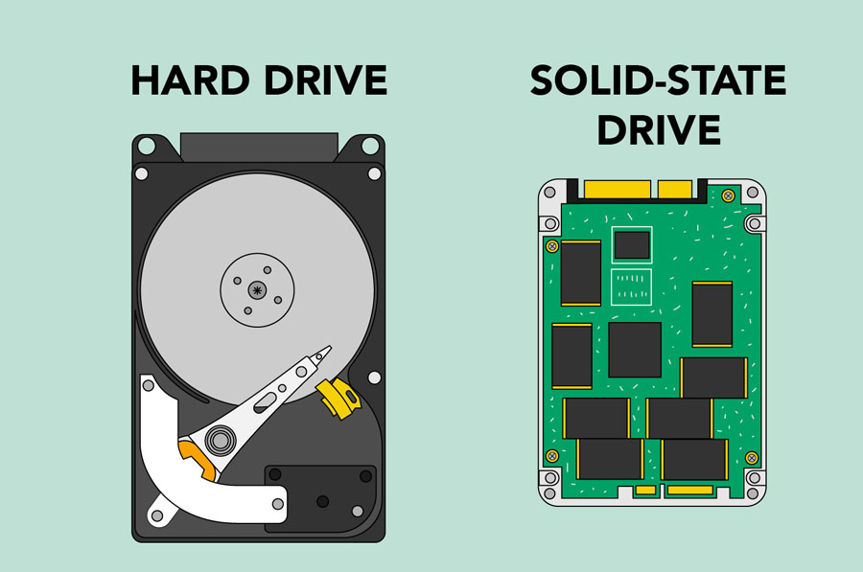

#### Power supply unit:

The power supply unit in a computer **converts the power** from the wall outlet to the type of power needed by the computer. It sends power through cables to the motherboard and other components.

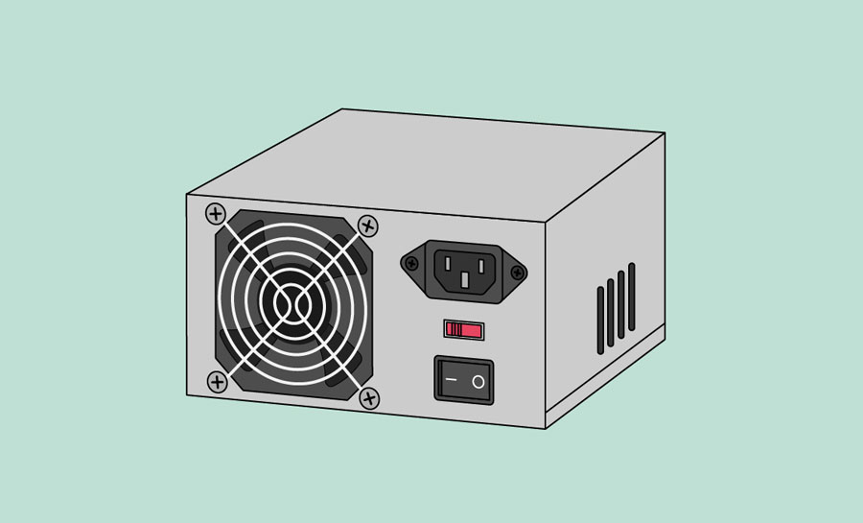

### Expansion cards:

Most computers have **expansion slots** on the motherboard that allow you to add various types of **expansion cards**. These are sometimes called **PCI (peripheral component interconnect) cards**. You may never need to add any PCI cards because most motherboards have built-in video, sound, network, and other capabilities.

* Video Card.
* Sound Card.
* Network.
* Bluetooth Adapter Card

E Experiment 02: HELP COMPUTER CLASSES

**Microsoft**

**Word 2016** LEVEL 1

**kcls.org/techtutor**

Microsoft Word 2016 Level 1 Manual

# Microsoft Word 2016 – Level 1

Welcome to *Microsoft Word 2016 - Level 1*. In this class you will learn the basics of Word, and work on a small project. You will connect to online tutorials and courses to reinforce and advance your learning. As you’re going through the class, think about how you could use Word at home or work.

**Contents**

**What is Microsoft Word?** ...................................................................................................................................................... 1!

Word 2016 Welcome Page ................................................................................................................................................. 2!

**Microsoft Word 2016 Interface** ......................................................................................................................................... 2! The Ribbon ............................................................................................................................................................................... 2!

Quick Access Toolbar ........................................................................................................................................................... 3!

File Menu .................................................................................................................................................................................. 3!

Title Bar, Help Menu, Ribbon Display Options ............................................................................................................ 3!

**Using Tools in Word** ................................................................................................................................................................ 4! Save Your Work ...................................................................................................................................................................... 4!

Get Ready for Typing ............................................................................................................................................................ 5!

Selecting Text ......................................................................................................................................................................... 6!

Home Tab ................................................................................................................................................................................. 6!

Insert Tab ............................................................................................................................................................................... 10! **One-on-One Help, Classes, and Online Courses** .................................................................................................... 12!

**What is Microsoft Word?**

Word is used to “create beautiful documents, easily work with others, and enjoy the read.” The types of documents you can create with Word include:

! **Letters** – personal, business (including résumés), creative or general notes

! **Notices** – basic flyers, menus, checklists

! **Reports** – for school, work or a special interest group

Word has excellent tools and a work area that resembles a sheet of paper. Word Word 2016 desktop icon templates on the Welcome Page offer pre-designed documents. Browse them to visualize what is possible with Word. Click on a template to see a description and suggested use for the template.

**1**

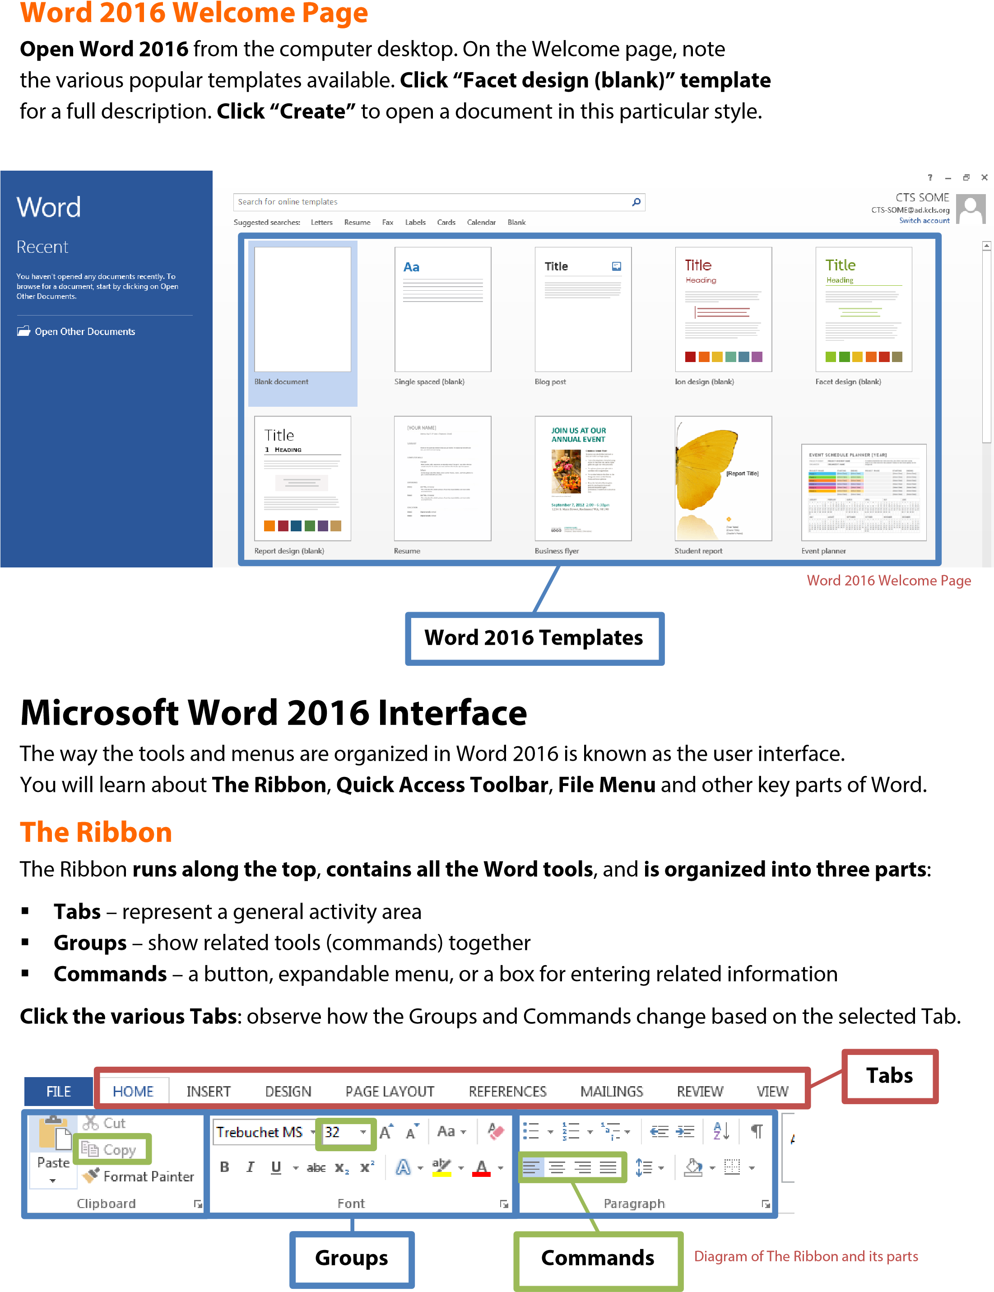

## Quick Access Toolbar

The Quick Access Toolbar is above the Tabs and **has commands used most often**, including “Save”.

**Place the mouse arrow over each icon** **(do not click) to see the name and use for each icon**. c

You may customize the commands in the toolbar if you click the black arrow at the end of the toolbar.

**The Undo command “takes back” any changes** made to the document. For example, type “Undo” in the blank document you have open, then click Undo in the Quick Access Toolbar. Undo keeps track of actions by sequence; if you accidentally erase (change) data in your file, click Undo right away to get it back. On that note, it is important to “save early and save often.” (See “Saving Your Work” on page 5.)

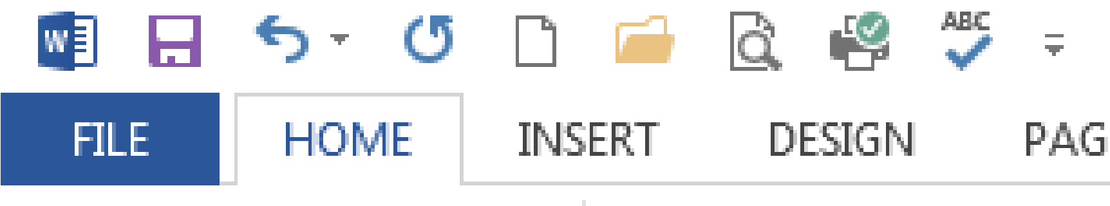

**Save Undo Quick Access Toolbar**

Quick Access Toolbar & “Undo” button

## File Menu

**The File Menu contains actions at the file level**. Click the blue “File” tab to the far left of the tabs. What you’ll see is the “backstage” area. From here, you can create a **New** document, **Open** an existing one, **Save** changes to the current document, **Save As** a different file with a different name, **Print** the current document, and other options. Click the “back arrow” at the top to exit the backstage area.

## Title Bar, Help Menu, Ribbon Display Options

**The Title Bar shows the name of the program and the name (title) of your document**. (Top-most bar in program window.) A new document has a temporary title, *Document1*, until you “Save As” with a different name. To the far right on the Title Bar is the Help Menu and Ribbon Display options.

The **Help Menu** has articles on using the software. Not sure how to perform a certain action or where to find a command? Click the question mark icon to browse Help articles, or search for specific topics.

**Ribbon Display Options** allow you to see more or less of the Ribbon and the work area, as a result.

**Take a moment to locate and explore these features in the Word program window.**

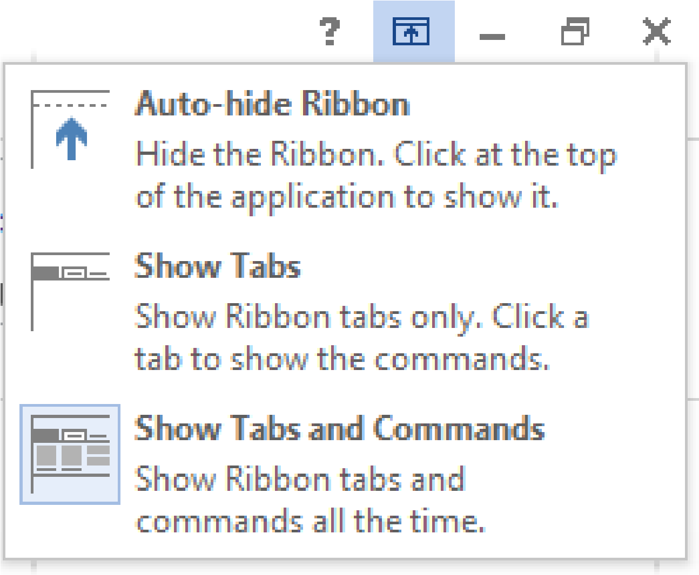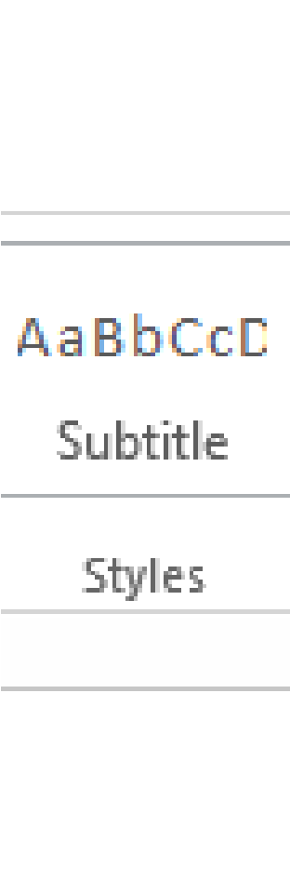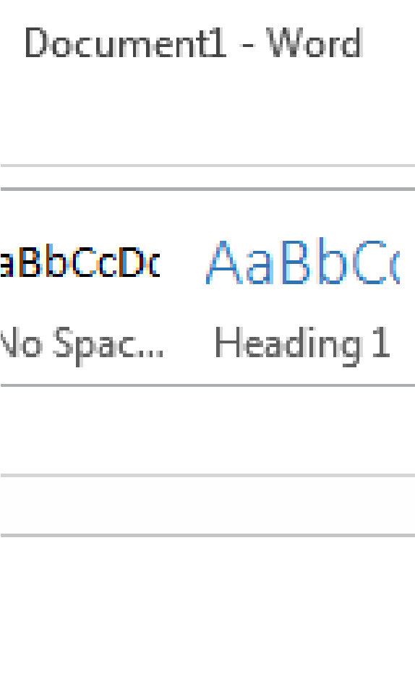

**Title Bar**



**Ribbon Display Options**



**Help Menu**



Title Bar, Help Menu & Ribbon Display Options

## Using Tools in Word

Start learning about word processing by working in a **Microsoft Word 2016** document.

### Save Your Work

To make sure you don’t lose your work on a document, you should “save early and save often.” Let’s start by saving the document you have open in Word 2016:

1.! **Click the blue File Button** **near the Tabs**. Learn more about “File Menu” on page 4.

2.! **Click Save As**. This option is for saving, or naming, a file for the first time. You may create different versions of a file by “saving as” a new name. Learn more in “Quick Access Toolbar” on page 3.

3.! **Click “Computer”**. See **TIP** below and “Saving With OneDrive” (page 11) for “cloud” storage info.

4.! **Click “My Documents” folder**. On KCLS computers, files saved to “My Documents” folder are erased at the end of your session. Consider a USB drive, or OneDrive for long-term storage.

5.! **Name file “My Practice Document”**. Generally, choose a name that is easy to remember.

6.! **Click Save**.

! **TIP**: Have a Microsoft account with Outlook.com, Hotmail.com or Live.com? Microsoft Office 2016 Programs offer **“cloud” file storage through OneDrive**. Click OneDrive instead of “Computer” to log in, save the file and access anyplace through the Internet. Learn more at bit.ly/office2016cloud.

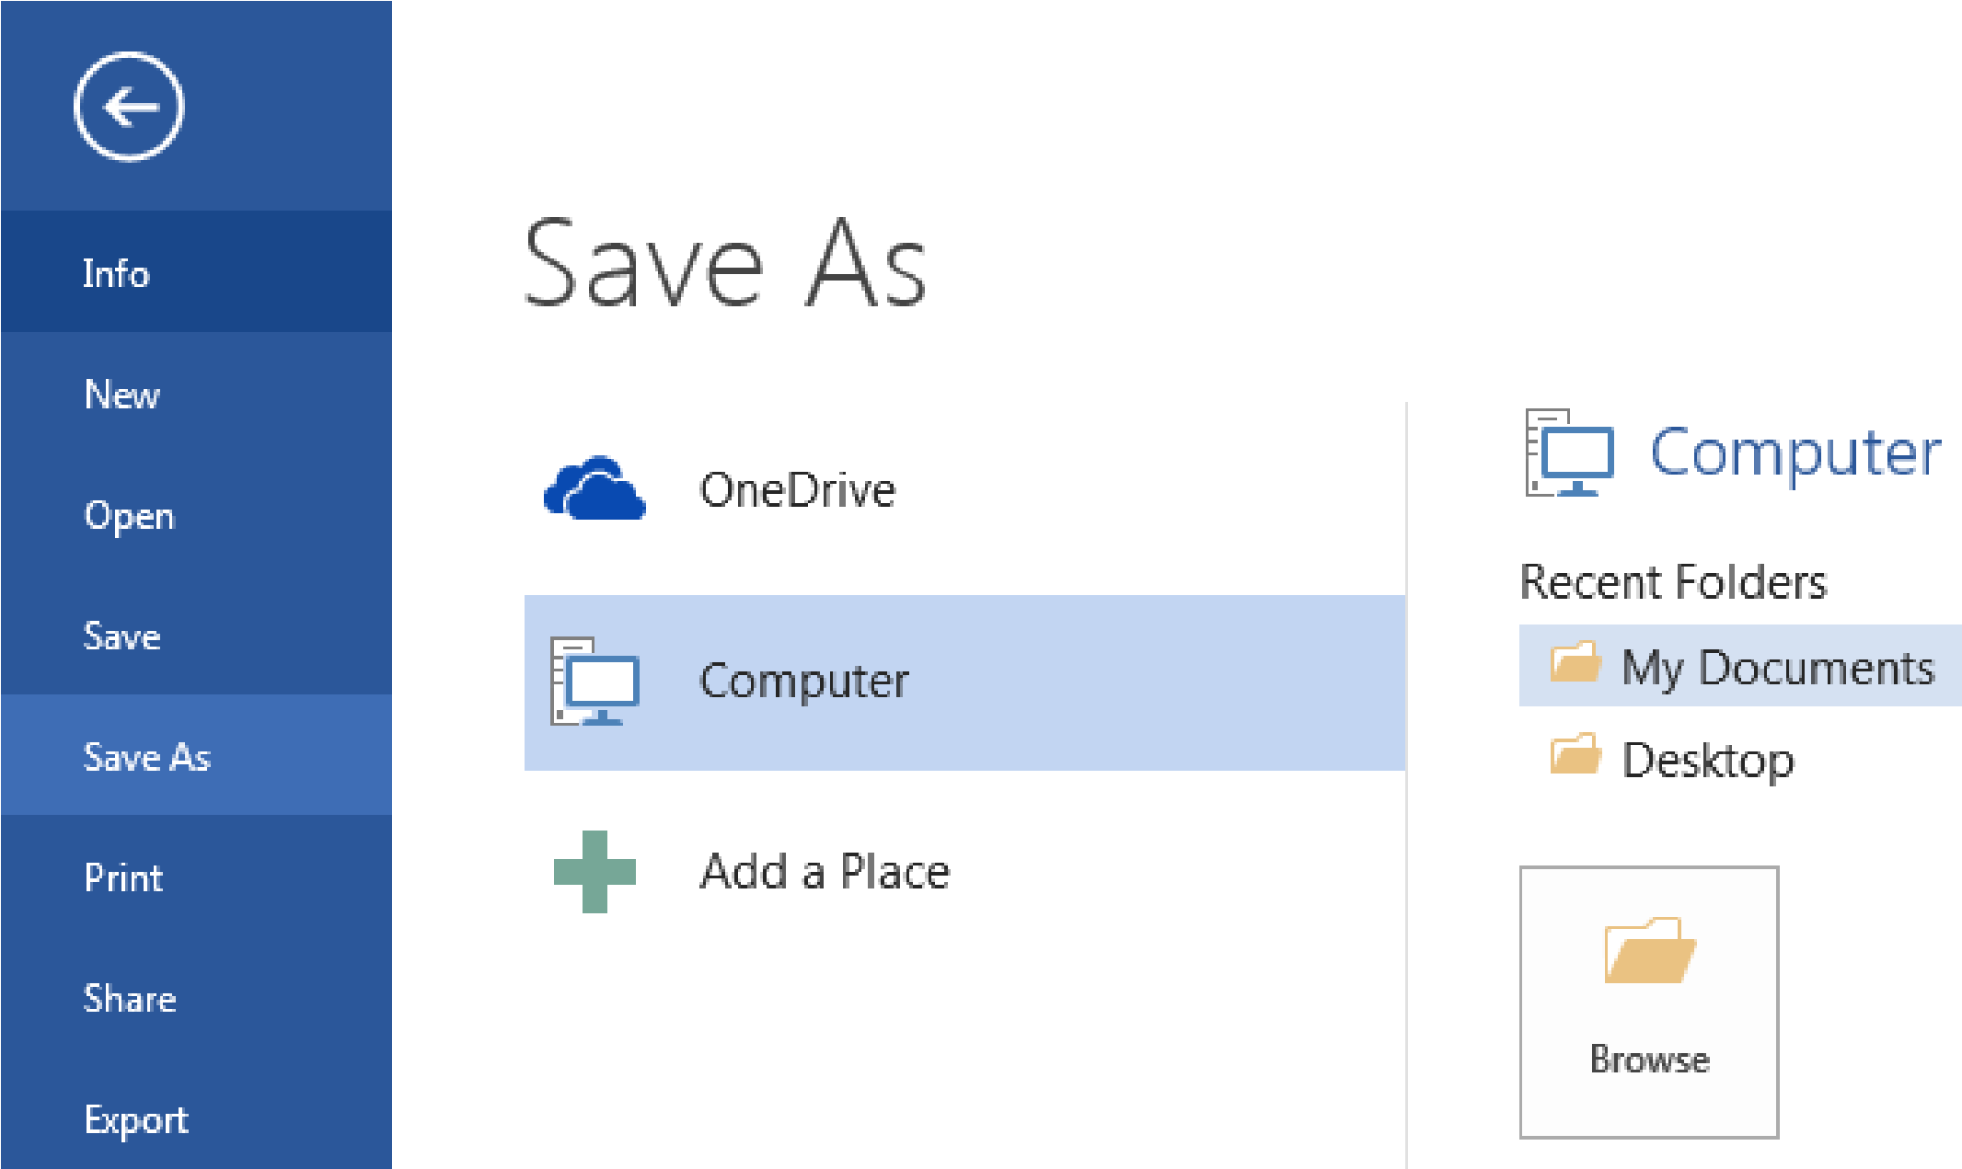

Word 2016 Backstage View – “Save As” to “My Documents” on KCLS computers

### Get Ready for Typing

The main workspace in Word resembles a piece of paper on your screen. Note the vertical blinking line, the cursor, near the top left of the paper. Cursor and mouse pointer shape offer hints in Word.

#### The Cursor

**The cursor indicates where text will appear as you type; it also indicates font size for that spot**. Earlier, you created a document from the “Facet design (blank)” template on the Welcome Page. Note the size of the cursor next to the word “Title”. What is the font size value for the word “Title”? (Look toward the Font Group in the ribbon.)

Now move your mouse pointer in front of the word “Heading” and left-click once. This moves the cursor. Note the cursor size and font size value in the font size box. What is the font size value?

#### Mouse Pointer Shape

**You may have noticed the mouse pointer changes shape as you move to different areas in Word.**

The two most common shapes indicate different functions. The **mouse pointer arrow** is for clicking commands, or buttons in general. The **mouse pointer text tool** (I-Beam) is for selecting text or positioning cursor for typing. You will use the document you have open now to practice using various key Groups and Commands in the Word

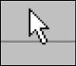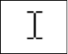

Mouse pointer

arrow



Mouse pointer text tool

Ribbon. Let’s select and change text in your document.

### Selecting Text

Selecting text to make edits is an important word processing skill. **A common way to select text is**:

1.! Place mouse pointer text tool next to the text. In this case, place it next to next to “T” in “Title”.

2.! Press the left mouse button.

3.! Drag it across the text.

4.! Let go of the left mouse button.

Notice “Title” is selected (highlighted). Go ahead and type “My Practice Document”.

#### Selecting Lines and Paragraphs

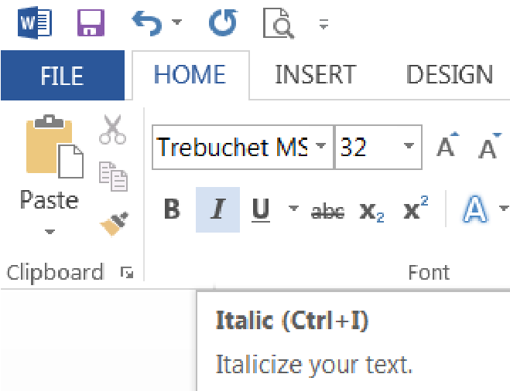

**To select a complete line of text** (use paragraph in your practice document):

1.! Place mouse pointer arrow in left margin next to line of text (arrow will point to the right).

2.! Left-click once to select that line of text.

**To select several lines or a paragraph**:

1.! Place mouse pointer arrow in left margin next to line of text (arrow will point to the right).

2.! Press (hold down) the left mouse button.

3.! Drag to the end of the paragraph.

4.! Let go of the left mouse button.

**Next, you will use commands from the ribbon to edit text you have selected**.

### Home Tab

The Home Tab has the groups of commands that people use most often. **Font Group**

The Font Group contains commands that change the appearance of the font. Font is the set of characters (letters, numbers, punctuation, etc.) in a particular style. For example, the document you created from the “Facet design” template on the Welcome page uses “Trebuchet MS” font, but you can still use the font commands in your document.

**Here’s how to italicize text**

1.! Select the word “Practice” in the document title.

2.! Click italics icon in Font Group (see screenshot).

! **TIP**: Italic, like Underline, is used to emphasize words or sentences in text, and book and movie titles. Though italics are more common, you can use either in your documents, but use one consistently throughout.

**Next, select “Heading” and type “how to use this template”.**

! **TIP**: After selecting text, access common tools quickly in the floating format box.

Notice Word automatically capitalized the first word in the sentence. If you want each word capitalized, as a title or header normally is, you may do it word by word or simply use **Change Case**.

**To use Change Case command**

:

1.

!

Select “How to use this templa

te”.

2.

!

Click “Change Case” command.

3.

!

Click

“Capitalize Each Word” in menu.

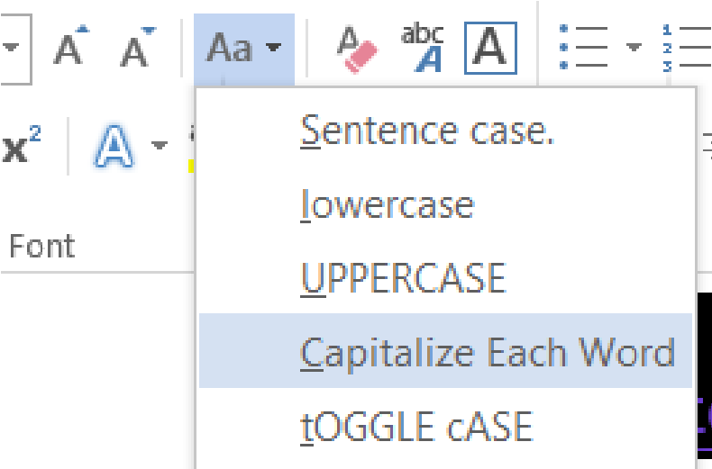

Change Case command button and menu



! **TIP**: A general rule to make changes to text is first select the text and then click the command button of your choice. You may change font size or style before you start typing, too. Look in the Font Group to see the font and size that will appear when you begin to type.

**Take a moment to read the paragraph in your practice document under “How To Use This Template”. You will use some commands from the Styles Group and Paragraph Group under the Home Tab.**

#### Style Group

A document created from a template, like the one you opened earlier (Facet design blank), has predesigned styles for different parts of the document, such as paragraphs and headers.

**To apply a different paragraph style**:

1.! Select paragraphs under “How To Use This Template”.

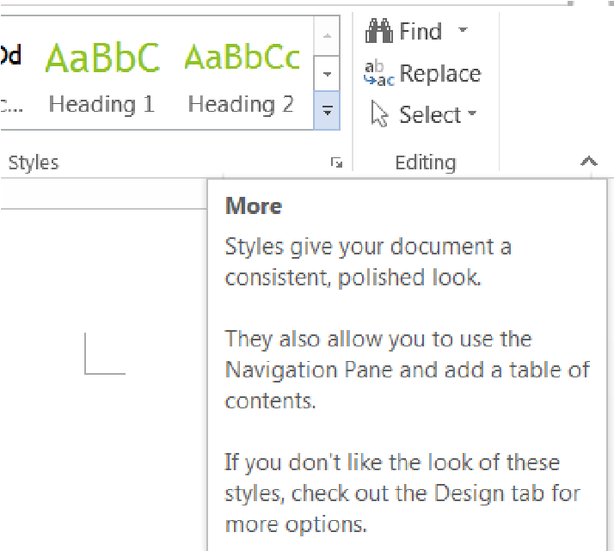

“More” button in the Styles Group

2.! Click “More” button in Styles Group.

3.! Click “Emphasis” command.

The text remains selected. You may continue modifying, including Undo, if you wish. To de-select, press left arrow (cursor placed at beginning of text), right arrow (cursor placed at end of text) or click in an area outside the selection.

**To create a new heading (section)**:

1.! Click “More” button in Styles Group.

2.! Click “Heading 1”.

3.! Type “Learning more about the home tab”.

4.! Press “Enter” once.

5.! Type “The Home Tab contains the following Groups:”

6.! Press “Enter” once.

You now have a new header and introductory sentence. You will use commands from various groups at various times, so don’t be surprised that you will use a command from the Paragraph Group next.

**To create a bulleted list**:

1.! Click “Bullets” command in Paragraph Group.

2.! Type “Clipboard”.

3.! Press “Enter” once.

4.! Re-create list pictured to the right (Repeat step 2 & 3 for each word).

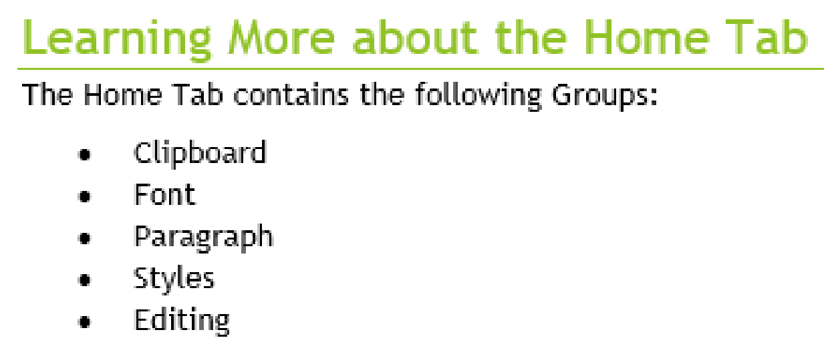

Your document header and bulleted list will look this.

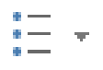

5.! After last item in your list, press “Enter” twice.

Bullets are good for general lists of items. A numbered list is good for steps in a procedure or order. The steps to make a numbered list are the same, except the icon for numbering is

! **TIP**: For style or space, explore decreasing indent space for lists. Bullets or numbers automatically indent to set lists apart from regular text. But if you like the style of left margin alignment, the bullets or numbers set the list apart from the text sufficiently.



Indentation command buttons

#### Clipboard Group

The Clipboard Group has the commands to do “copy and paste” and “cut and paste”.

**Before you start**:

1.! Make a new sub-heading in your practice document.

a.! Use “Heading 2” style from Styles Group.

b.! Type “Clipboard Group”.

c.! Press “Enter” once.

2.! Type two sentences on one line.

a.! “I want to live in a warm place. I am moving to Hawaii.” **To Copy and Paste text**:

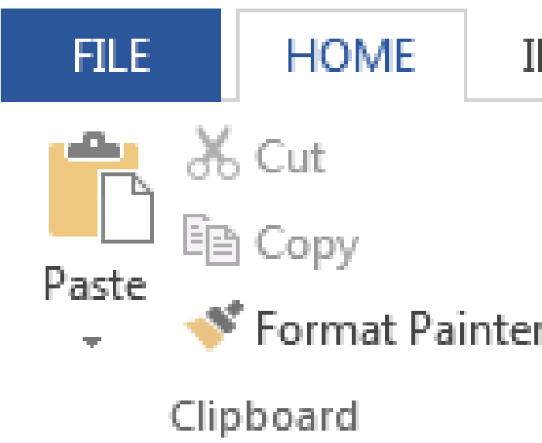

Clipboard Group under the Home Tab

1.! Select the text (the line of text you just typed).

2.! Click “Copy” icon in Clipboard Group.

3.! Move cursor to area where you want to paste (right arrow, then “Enter” once).

4.! Click “Paste” icon in Clipboard Group.

**To Cut and Paste text**:

1.! Select the text (the sentence “I am moving…”).

2.! Click “Cut” icon in Clipboard Group.

3.! Move cursor to area where you want to paste (at beginning of first sentence on same line).

4.! Click “Paste” icon.

Can you think of a scenario where you might choose one command (Copy, Cut) over the other?

! **TIP**: Use keyboard shortcuts to save a little time. When you place the mouse pointer arrow over a command without clicking, a floating box appears with the command name, keyboard shortcut in parenthesis and a brief description.

**Paragraph Group**

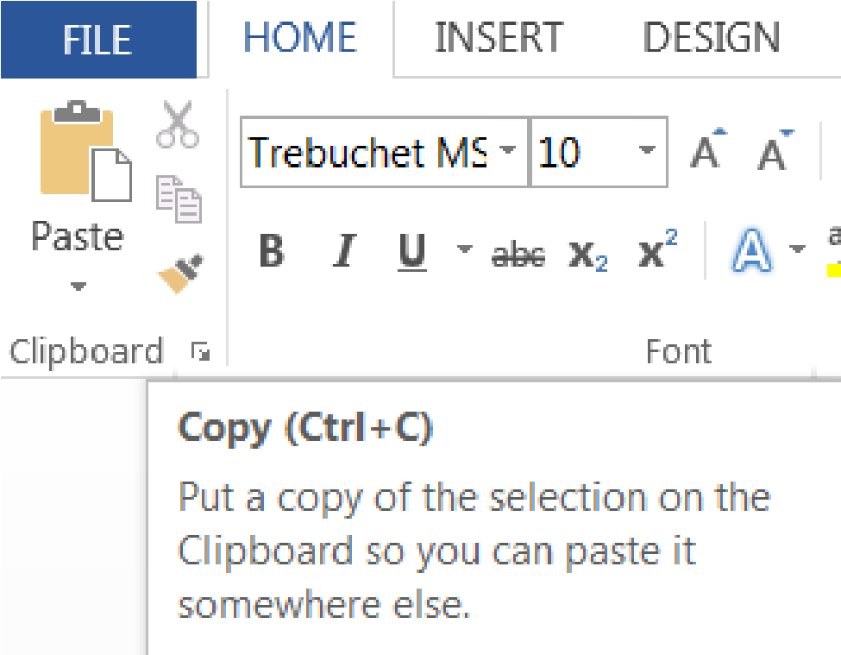

Floating box with name, shortcut and

description of Copy command

The Paragraph Group includes commands to adjust line and paragraph spacing and alignment.

**Line spacing** refers to when the text you’re typing has reached the end of the line and moves down to the next line automatically. **Paragraph spacing** refers to any time you press the “Enter” key to start a new paragraph.

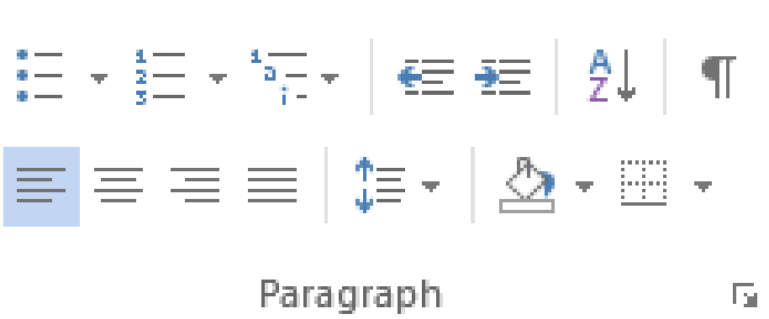

Paragraph Group and “Line and Paragraph” command highlighted

**To practice spacing and other commands in the Paragraph Group, open Paragraph Practice doc**:

1.! Go to **kcls.org/techtutor**

2.! Scroll through the cards to find “Exercise Files for Tech Tutor Manuals” and click that card

3.! Click on “Paragrah Practice” under the “Word” section

4.! Click “OK” to open

5.! You may prefer to change to “Print Layout” under the “View” tab

### Insert Tab

The Insert Tab commands insert different elements into your document like tables and illustrations.

#### Tables Group

You may choose preformatted tables or add the number of rows and columns you want. For this exercise, you will create a 3x5 table to track DVD’s on loan to friends.

**To insert a table into your**

**document**

:

1.

!

Click the

Add a

Table

icon under the Insert Tab

.

2.

!

Select a 3

-

column, 5

-

row area in the grid.

3.

!

Left

-

click when you are ready to insert the table.

**Apply a Table Style**

1.

!

Click into the table to activate the Ta

ble Tools tab

.

2.

!

C

hoose a new design

from the Design Tab

.

**C**

**omplete table as shown**

**below**

:

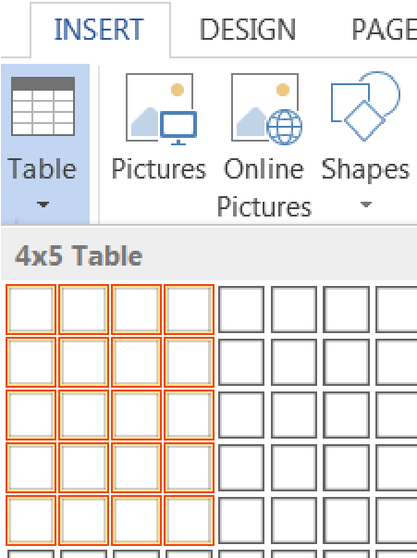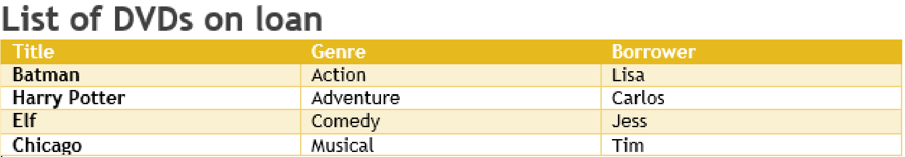

Table grid selection area

! **TIP**: Sort the list of DVDs to locate them easier (imagine if you had a longer list). Click into the table to activate. Under the Layout tab, click Sort to sort by title (you could also sort by name if you wanted to know who had what movies).

#### Illustrations

The Illustrations Group has commands to insert pictures*,* shapes, charts, and more.

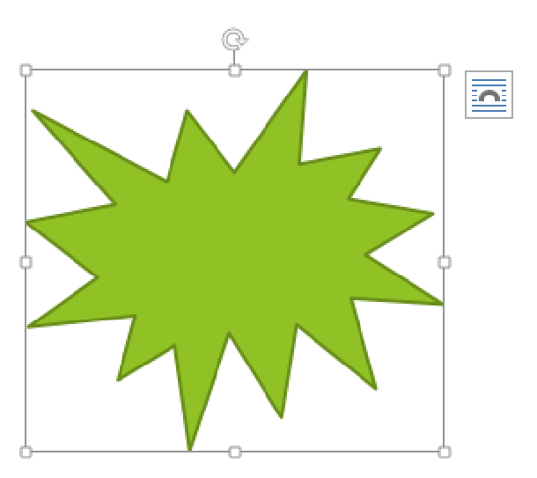

“Explosion 1” shape with active frame for re

-

sizing and layout options button

**How to insert a shape**

1.! Click the Shapes button in the Illustrations Group 2.! Click the first shape (Explosion 1) in Stars and Banners.

3.! Place mouse pointer (cross) in a blank area.

4.! Click and drag your mouse to “draw” the shape.

5.! Let go of the mouse button when finished.

**How to add text to a shape**

1.! Place mouse pointer arrow in shape area.

2.! Click right mouse button once.

3.! Click “Add Text” from menu.

4.! Type “Hello”.

**How to move a shape**

1.! Place mouse pointer over shape.

2.! Look for cross-like move arrow tool.

3.! Click and drag your shape to a new spot.

**How to re-size a shape**

1.! Click into the shape.

2.! Look for squares around the frame.

3.! Click and drag a frame square.

a.! Drag a corner out to enlarge proportionally.

Steps for inserting other types of illustrations are similar; try inserting another illustration on your own.

**Word Help**

The

Help Menu is an excellent resource for learning how

to use software.

Click the question mark icon

near the

top right corner of any

Office

2016

program window to

access Help content.

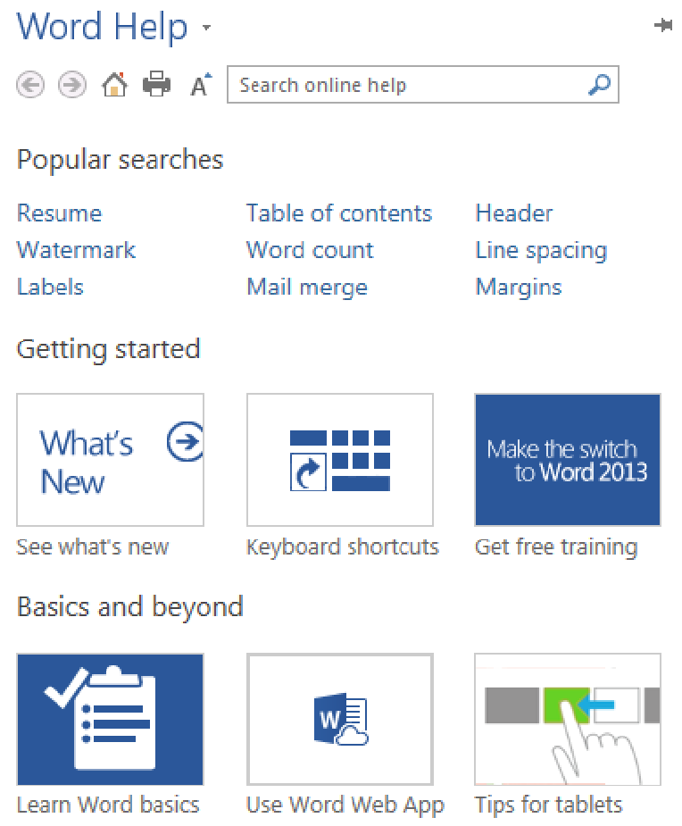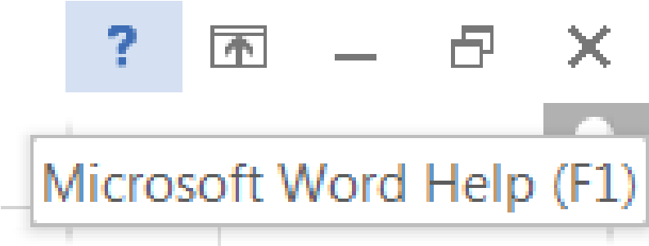

**Help**

**Menu icon**

#### Keyboard Shortcuts

These shortcuts are a handy way to use the mouse less. Activate them by holding down one of the *Ctrl* (Control) keys on the keyboard and tapping the corresponding key. For some shortcuts, you have to highlight the text first. Follow your instructor’s directions to apply these shortcuts to a document (if Paragraphs document is still open, use it as an example or write a few new sentences on a blank page).

|  |  |
| --- | --- |
| **Ctrl + P** | **print** |
| **Crtl + A** | select all |
| **Ctrl + C** | copy |
| **Ctrl + V** | paste |
| **Ctrl + X** | cut |
| **Ctrl + N** | opens **new** window/document |
| **Ctrl + S** | save |
| **Ctrl + Z** | undo |
| **Ctrl + Y** | redo |
| **Ctrl + B** | bolds **text** |
| **Ctrl + I** | *italicizes* text |
| **Ctrl + U** | underlines text |
| **Ctrl + ]** | enlarges text by one size |
| **Ctrl + [** | decreases text by one size |
| **Ctrl + E** | **centers text** |
| **Ctrl + L** | aligns text to the left |
| **Ctrl + R** | **aligns text to the right** |
|  |  |
|  |  |